How to create a Console Application with Visual Studio 2005 Professional

This is what you will see when you start it up.

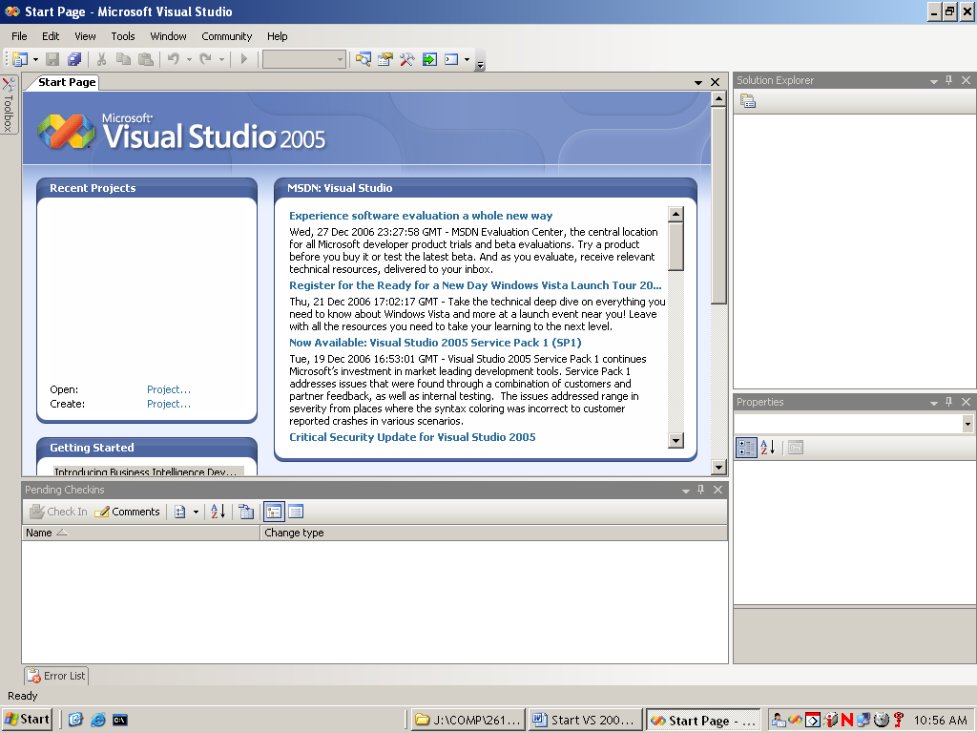

You can close the Start Page and the Pending Checkins pages. Then it will look like:

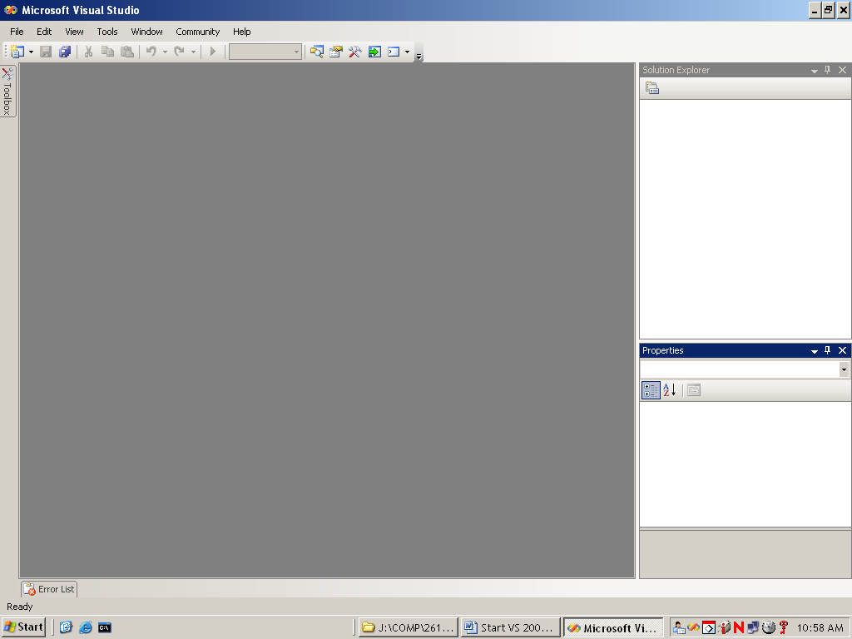

Start by creating a project: File >>> New >>> Project …

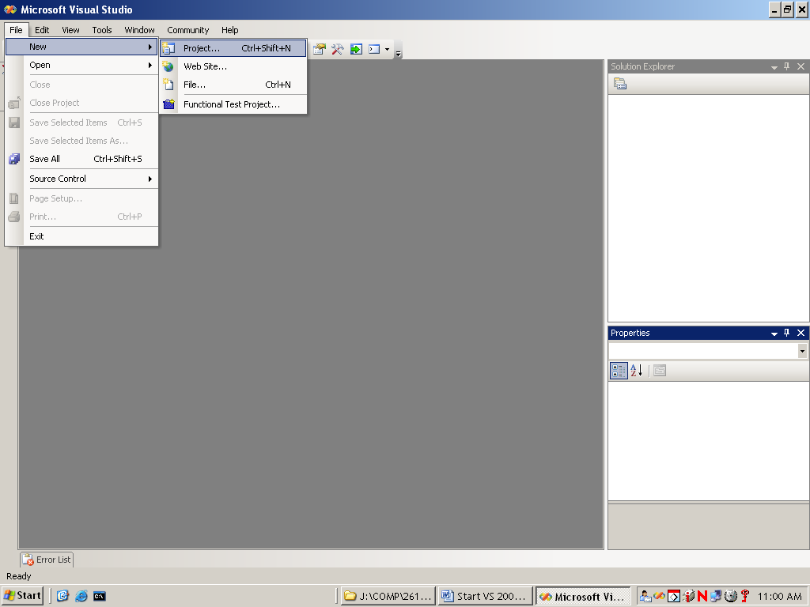

In the “New Project” window that pops up (see screenshot below),

- Expand “Visual C++” and select “Win 32” in the left pane.
- Then in the right pane select “Win32 Console Application”.
- Then type in the project name (“BobProj” in the sample screenshot below).
- Then set the location where you want your project to be created. The default location is usually ok, but note where it is so that you can find your project later. You may specify the location if you wish using the “Browse …” button.
- Unselect “Create directory for solution” to prevent an extra level of folders from being created. Not a problem if you forget, but more of a nuisance.
- Finally, select the “ok” button.
If you are doing a project on a computer in a BCIT lab, you should create your project in the “Work” folder (as in screenshot below). This is because the Work folder is the only folder that will not be automatically “reset” to its original state when you log out. If you accidentally log out or if your computer crashes, the contents of the Work folder should remain intact and should still contain your project folder when you log back in.

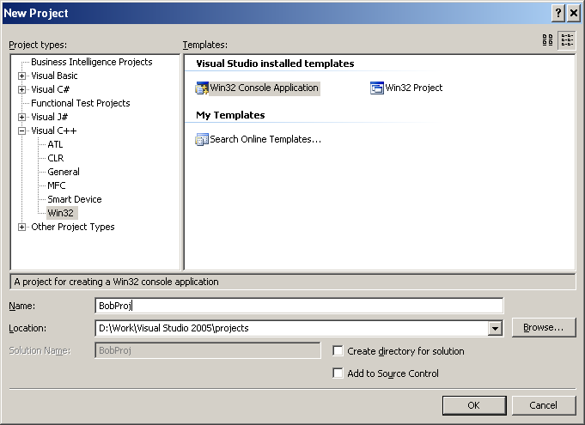

Next select Application Settings, choose the settings indicated below and then press “Finish”. Note that it is very important that you select the “Empty project” check box!

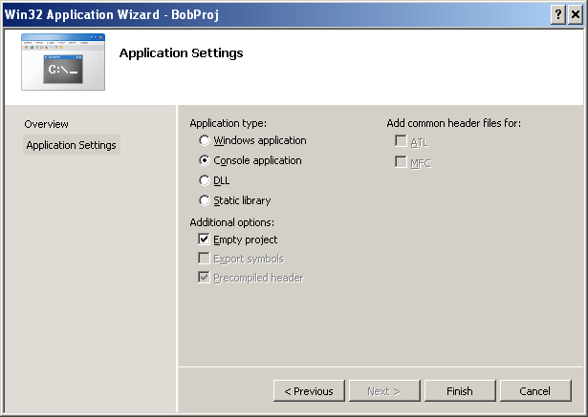

At this point you might want to move any existing source files you want to include in your project into the project directory folder. It is not absolutely required, but it is strongly recommended – it leads to less problems!

Below is how you add an existing source file(s) to your project. Right click on the project name in the “Solution Explorer” window (normally near the top right of your VS 2005 IDE), choose “Add” and the choose “Add Existing Item…”.

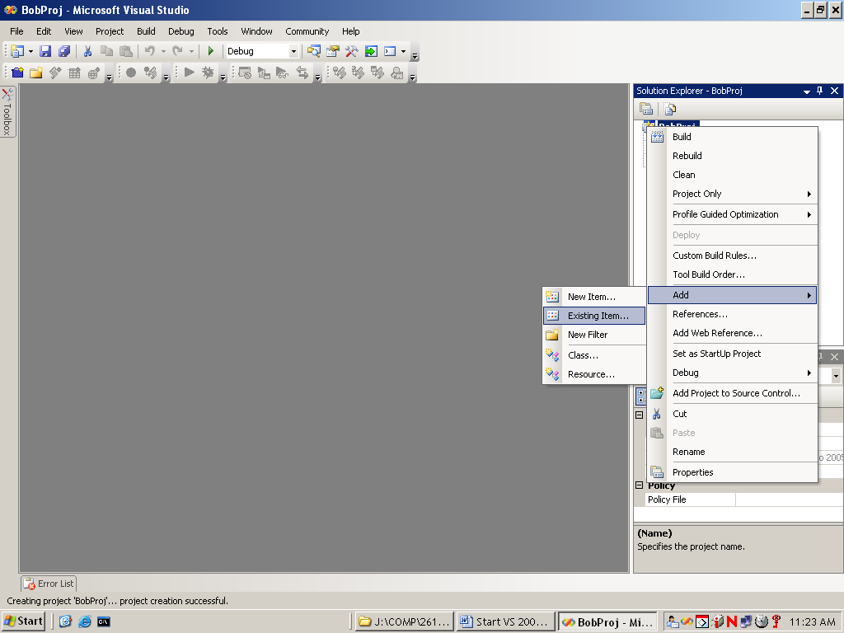

This will normally cause a window to open showing the files in the default location – the project directory (which is another reason to put the files you want to include in your project into the project directory before doing this step). If the file(s) you want to add to the project is not in the default folder, you can use the drop down menu pointed to by “Look in:” to go to another folder. Then select the file(s) you want to add to the project and then select the “open” button.

Note to Comp 3476 students: The default file type specifier does not include .i type include files. You may need to change the “Files of type:” field to “All files (*.*)”, as I did below.

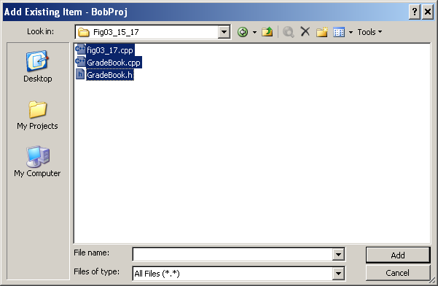

Below is how you add a new source file to your project. Right click on the project name in the “Solution Explorer” window (normally near the top right of your .NET 2005 IDE), choose “Add” and the choose “Add New Item…”. You will note this step is almost identical to adding an existing file to your project.

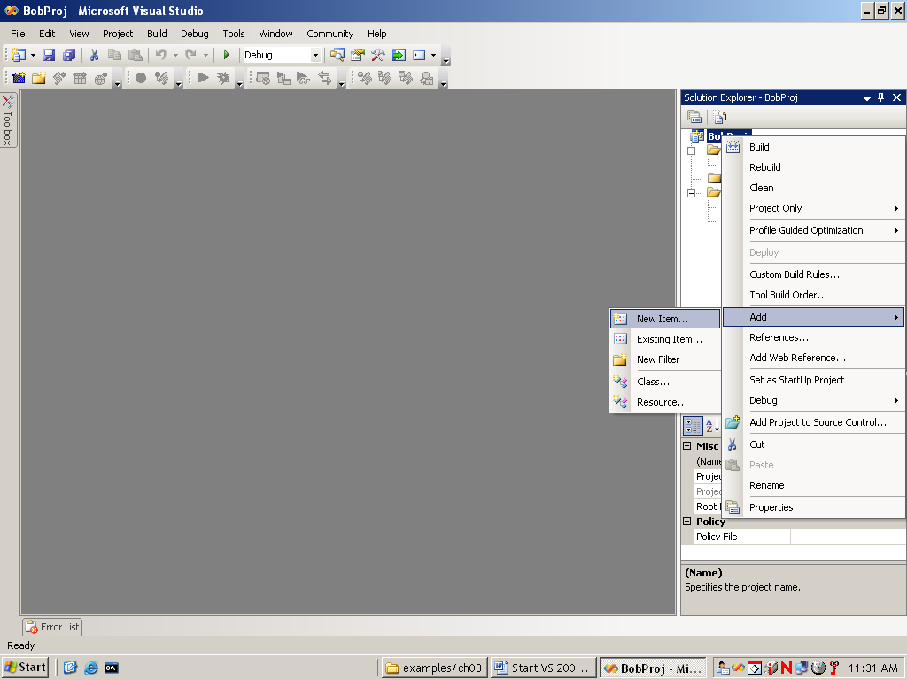

A new window will pop up where you will specify the type of file you want to add to your project (see below). You must also specify the file name for the new file you are adding to your project (“Test” in the example below).

PLEASE NOTE: If you are using the VS 2005 IDE to do C programming (instead of C++ programming), you must explicitly type the .c extension if adding a new source file (“Test.c” in the example below), or you will end up with a .cpp file instead of a .c file as required for C programming.

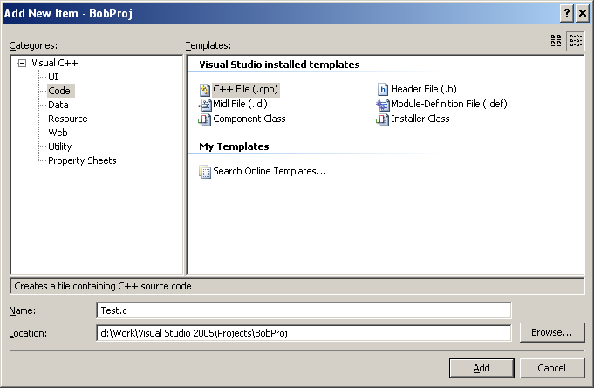

When you are ready to compile and link you go: Build >> Project Only >> Build Only <project name>. Use “Rebuild Only <project name>” instead if you wish to force the recompilation of all of the files in your project (normally not necessary).

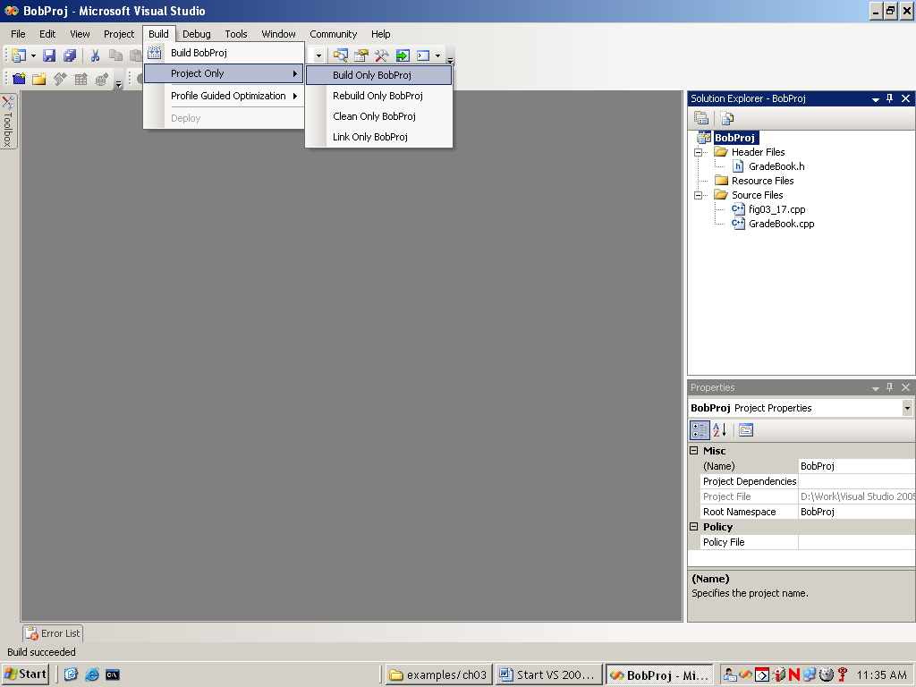

And if the build does not succeed, you will be shown errors in the “Error List” window. Otherwise, the build succeeded. Congratulations!

Now you are ready to execute your application: Debug >>> Start Without Debugging or Debug >>> Start Debugging (if you want to use the debugger).

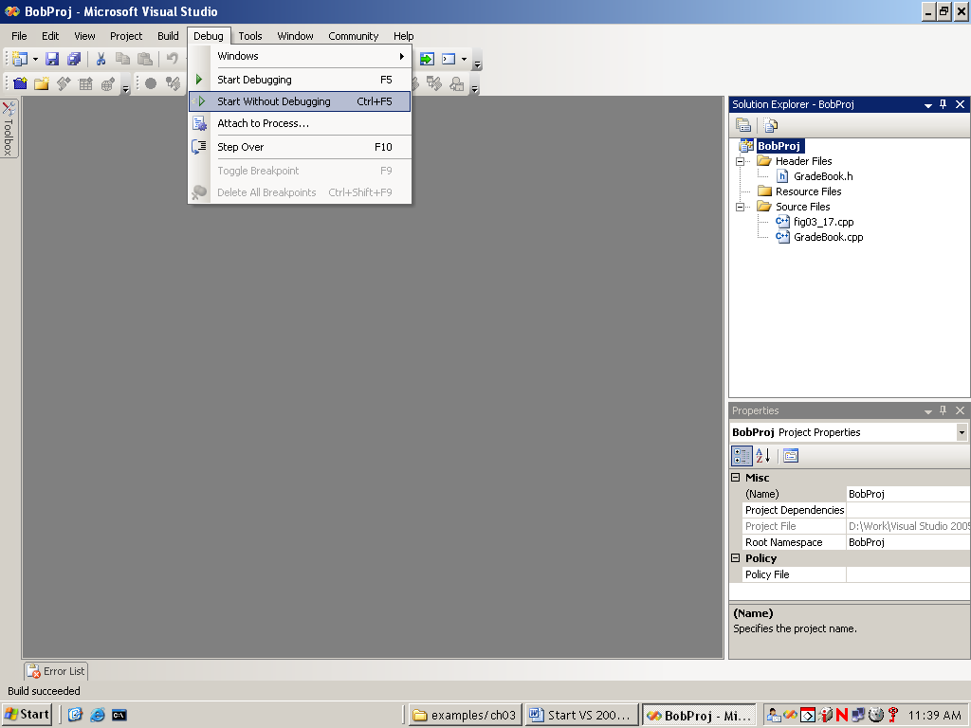

And hopefully you get something like this: for output:

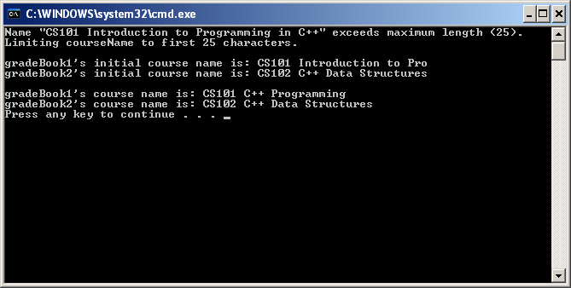

When you leave the project, you will only be prompted to save your changes if you have made changes since you last compiled your source files – the process of doing a compile saves all of the changes you have made to a source file.

If you have left the project and need to return, the most efficient way to do so is to mouse click on the project you want to open in the “Recent Projects” window.

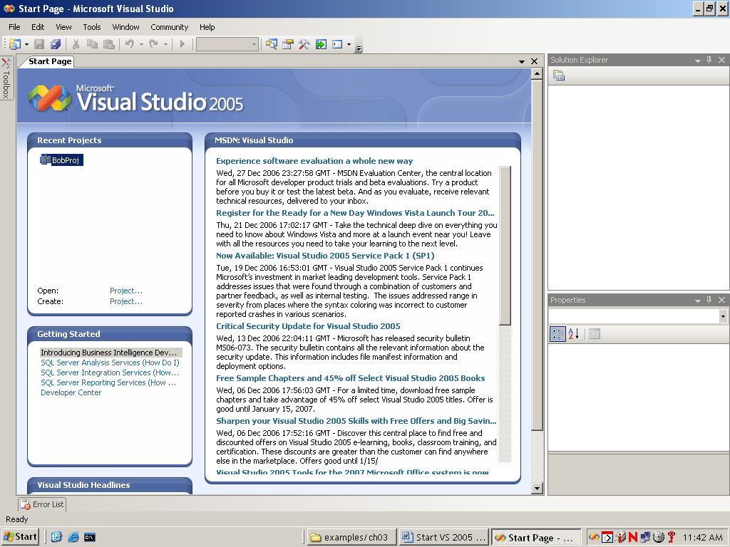

That all folks!!!

